Exploratory Analysis

Lab Task – 1

CASE DESCRIPTION:
This case study investigates the factors that contribute to student performance in final exams in HCT. The data for this study was collected randomly from 30 students’ performance in their exams spread around various departments and campuses.
This case study was conducted to get some insights into the factors that can affect student success in final exams visually through exploratory analysis. By understanding these factors, educators can develop strategies to help students improve their performance.
Chapters: Exploratory Analysis
Cognitive Levels: Apply, Understand

Aim:
Part 1. Applying the exploratory statistics
Summarizing and visualizing the data to reveal its key characteristics, relationships between variables, and potential outliers or errors. By utilizing python programming, you can visualize the data using:
- Scatter plot
- Box Plot
- Histogram
- Heat Map

Part 2. Applying the exploratory statistics
Develop the report including graphical representations such as histograms or box plots to visually depict the data distribution. This report is crucial in understanding the characteristics and patterns within the dataset and can aid in making informed decisions or drawing meaningful conclusions from the analysis.

Exercise 1- Exploratory Statistics
Cognitive Levels: Apply

As a data analyst, HCT expects you to evaluate students' performance on the final exam. Utilize Python to summarize the student's performance using exploratory statistics.

HCT wants to visualize the student performance in the exam:

Note: You have to use Marks.csv
Steps:
- Scatter plot
- Box Plot
- Histogram
- Heat Map

Answer:

Exploratory Analysis:

a. | Perform scatter plot of final marks for each student
import pandas as pd
import matplotlib.pyplot as plt

# load the data into a pandas dataframe
df = pd.read_csv('Marks.csv')

# create a scatter plot for Student ID Vs Final
df.plot.scatter(x = 'ID', y = 'Final', s = 100, c = 'red');
b. | Perform histogram for Quiz
import pandas as pd
import matplotlib.pyplot as plt

# load the data into a pandas dataframe
df = pd.read_csv('Marks.csv')

# create a histogram
plt.hist(df['Quiz'], bins=5, edgecolor='black')

# add labels and title
plt.xlabel('Score')
plt.ylabel('Frequency')
plt.title('Distribution of Exam Scores')

# display the plot
plt.show()
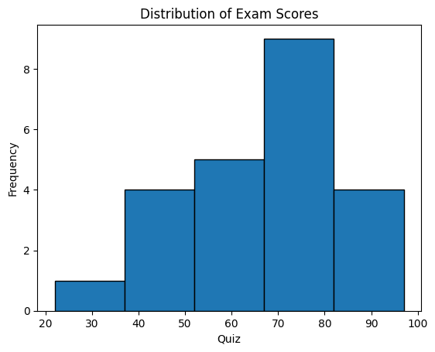
Note: In this histogram of Quiz, the quiz marks range from 22 to 97. Most of the students score 70 to 80 marks. Only one student score between 22 to 38 marks.
c. | Create a box plot for Quiz
import pandas as pd
import seaborn as sns

# load the data into a pandas dataframe
df = pd.read_csv('Marks.csv')

# create a box plot
sns.boxplot(x=df['Quiz'])

# add labels and title
plt.xlabel('Score')
plt.title('Distribution of Exam Scores')

# display the plot
plt.show()
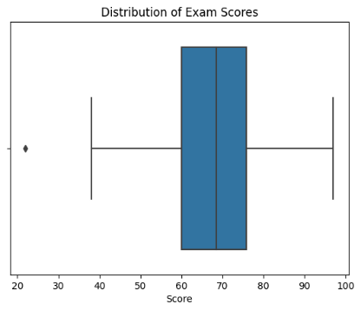
Note: Since outlier is detected, then delete from the dataset (in excel or using command)
d. | Create a heat map for Number of Students by Zone
# libraries
import pandas as pd
import seaborn as sns
import numpy as np
import matplotlib.pyplot as plt

# create data
df = pd.read_csv('Students.csv')

# plot
pivot_table = pd.pivot_table(df, index='Zone_EN', values='Student_Count', aggfunc='sum')
sns.heatmap(pivot_table, cmap='Blues')

plt.ylabel('Zone')
plt.title('Total Number of Students by Zone')

plt.show()

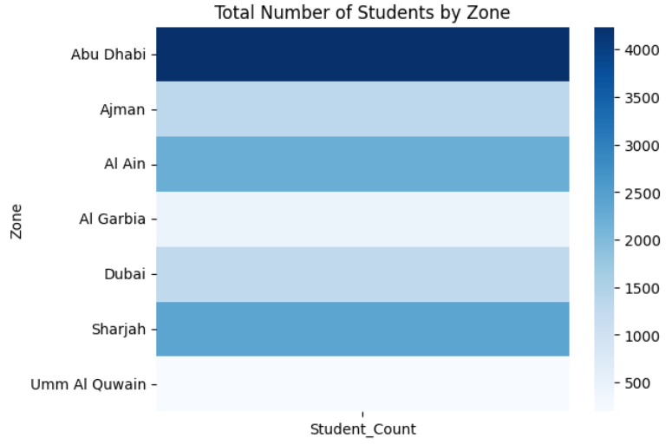
e. | Create a heat map for Number of Students by Zone and Gender
import pandas as pd
import seaborn as sns
import matplotlib.pyplot as plt

# Load the CSV file
file_path = 'Students.csv'
students_data = pd.read_csv(file_path)

# Creating a pivot table to summarize data by Zone and Gender
heatmap_data = students_data.pivot_table(
index='Zone_EN',
columns='Gender_EN',
values='Student_Count',
aggfunc='sum'
)

# Plotting the heatmap
plt.figure(figsize=(10, 6))
sns.heatmap(heatmap_data, annot=True, fmt=".0f", cmap="coolwarm", cbar_kws={'label': 'Number of Students'})
plt.title('Number of Students by Zone and Gender')
plt.ylabel('Zone')
plt.xlabel('Gender')
plt.show()
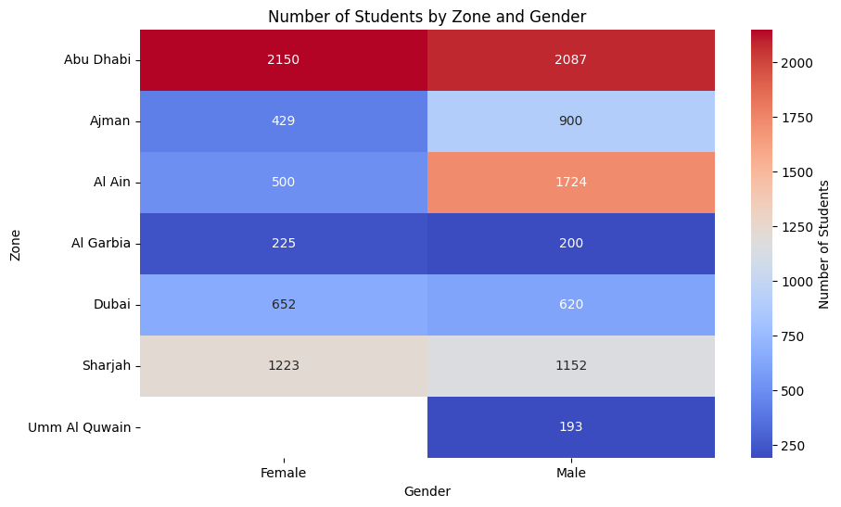
Note: Change the colour by cmap=”Greens” or cmap=”Blues”

Exercise 2- Exploratory Statistics Report
Cognitive Levels: Understand

Interpret your results using exploratoy statistics and submit a report to the HCT management.

An exploratory analysis report for the performance of students in the exam
The performance of HCT students in FWA is visualized in the following:
• Scatter plots: Used to show the relationship between the FWA mark and Project mark.
• Histograms: Used to show the distribution of FWA marks. This can be helpful for identifying any potential problems with the FWA marks, such as FWA marks inflation or deflation.
• Box plots: Used to show the median, quartiles, and outliers for student FWA marks. This can be helpful for identifying any students who are struggling or excelling.
• Heat maps: Used to show the relationship between different types of student grades. This can be helpful for identifying any areas where students are struggling or excelling.
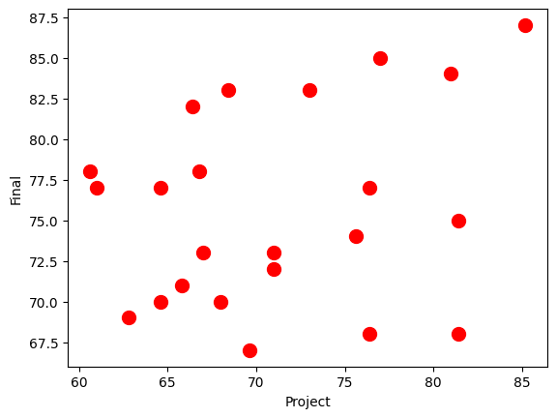
A scatter plot is plotted that shows the relationship between Project and Final marks. The graph shows that the points are scattered randomly, there is no correlation between the project and final marks.
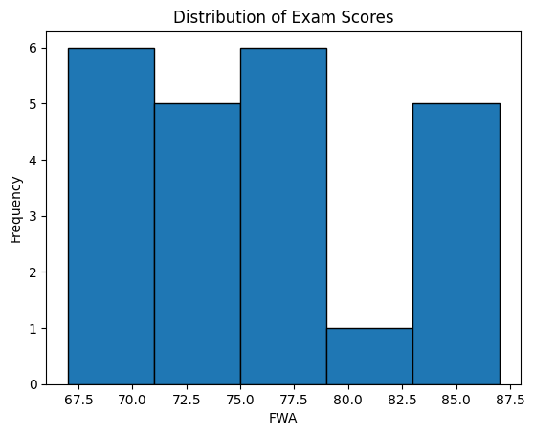
A histogram is plotted for final marks to understand the distribution of final marks. The final marks are divided into five bins, and the height of each bar shows the number of students in that bin. The graph reveals that
    - Around 5 students score between 82.5 to 87
    - Only one student scored between 79 to 82.5
    - Around 6 students score between 75 to 79
    - Around 5 students score between 71 to 75
    - Around 6 students score between 67 to 71
    - Left – Skewed
    - Min – 67 and Max – 87

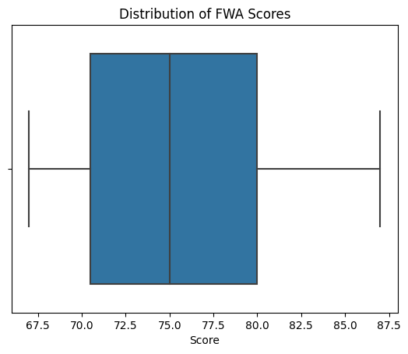
A box plot is plotted for final marks that show the distribution of final marks, as well as the median and quartiles. The graph reveals that the minimum FWA mark is 67.5, the maximum is around 87.5, and the average or median of the FWA mark is 75. The FWA marks are distributed between above 70 and below 80(inter-quartile range).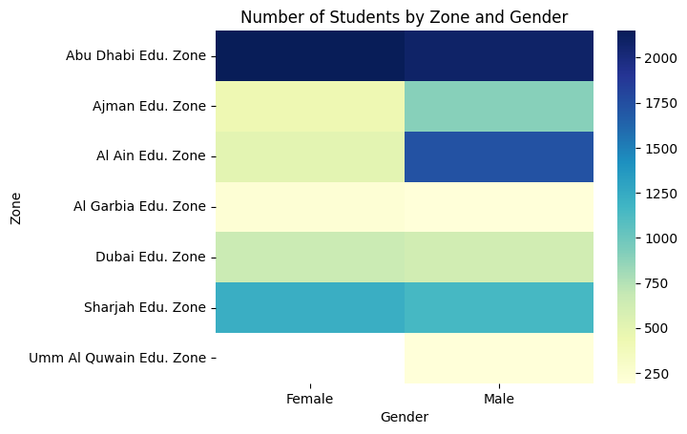
A heat map is plotted to show the number of students by Zone and Gender. The variables are plotted on the x-axis and y-axis, and the cells in the heat map are coloured according to the strength of the relationship. The darker the color, the stronger the relationship.
By interpreting these graphs, you can get a better understanding of how students are performing in the FWA exam and identify any areas where you may need to provide additional support.

